**Possible Types of Resistance from White Participants**

**Path to Competence©**

**Drs. Jack Gant and Delyte Frost  
Elsie Y. Cross Associates**

**Developed by Kathy Obear, Ed.D., *Center for Transformation and Change***

[**www.drkathyobear.com**](http://www.drkathyobear.com)

**Based on the work of Drs. Jack Gant and Delyte Frost, EYCA, Path to Competence©**

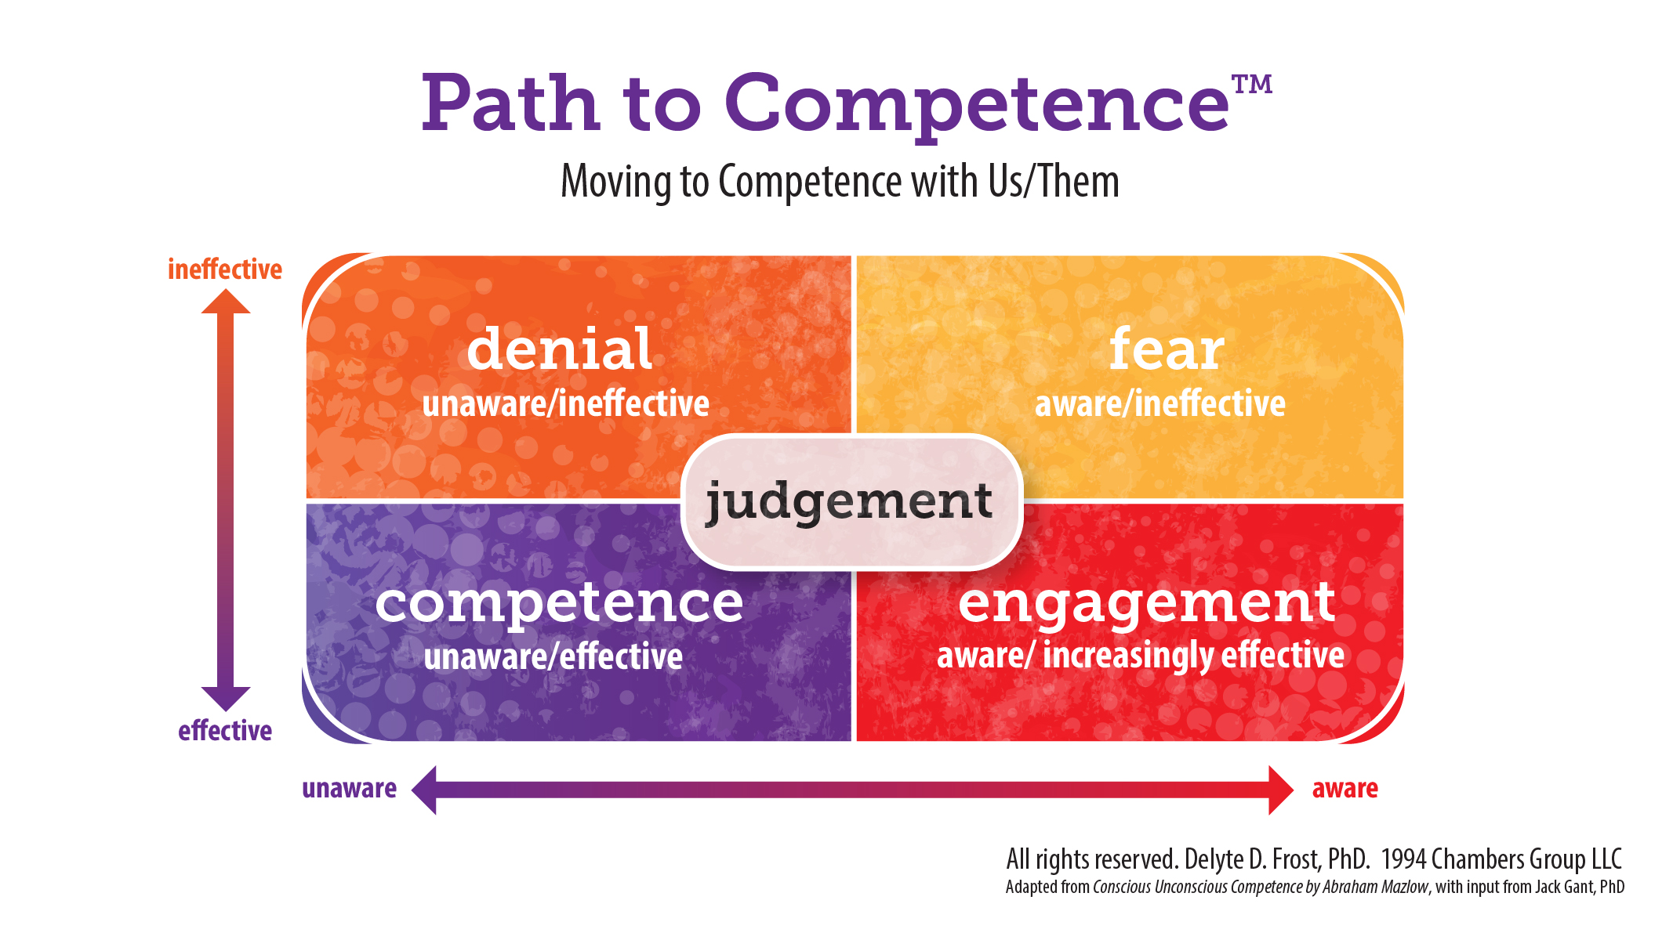

**Directions** ~ **Reflect & note:**

* When have you observed or done any of these behaviors?
* What **helped you shift your resistance**?
* What could you do to engage these comments and behavior?

**Box of Denial**: **unaware/ineffective**

* Tone policing of people of color: If they would only….
* They are too sensitive
* But they are racist, too!!
* They play the “race card”
* There are microaggressions against whites, too!
* Stuck at Individual Level
* We are post-racial
* Things are so much better now; what is the big deal?
* I’m not racist! I’m a good one
* That had nothing to do with race!
* PLEs ~ Perfectly Logical Explanations
* My best friend is black; I adopted Latinx orphans; I’m married to an Asian American
* You make it worse by segregating us, talking about race
* We are all human beings
* I’m part Native American
* I’m color-blind; I don’t see color!
* I treat everyone the same
* Deflecting to marginalized identity
* I grew up poor, I have no privilege
* Classism is the most important oppression
* Things have swung too far; now whites are discriminated against
* We can’t say anything anymore! Joke at all!
* We can’t learn without people of color
* We just have different opinions

**Box of Fear: increasing aware/ineffective**

* Tears with demand for attention, deflection
* Silence
* Shut down
* Defensiveness
* We can’t do anything right: Damned if we do, damned if we don’t!
* What do they want? Nothing will please them!
* It is never enough for them!
* It wasn’t my intent!
* Intellectualizing; Level Mismatch
* Focusing only on family racist dynamics
* Oppression Olympics

**Box of Judgment: maybe aware or unaware, still ineffective**

* I am so ashamed
* I am so guilty
* You attacked me! Accused me unfairly!
* Others are so racist!
* I’m better than these whites
* Wokeness Olympics
* I’m woke! Social Justice Arrogance, Call Out Culture
* I marched with Dr. King in the 1960s!
* Judging and critiquing other whites
* Critiquing how Co-conveners are running the group
* Whites giving unsolicited advice to others
* I am so incompetent; I can't do anything right
* Blaming others; blaming self
* I am bad; worthless
* All whites are bad
* Whites are boring; I’d rather hang out with my friends of color

**Box of Engagement: greater awareness/increasingly effective**

* I know all I need to know!
* I don’t have any more racist thoughts or behaviors
* I don’t need to practice anymore
* I’m not open to your feedback
* I do enough

**Developed by Kathy Obear, Ed.D., *Center for Transformation and Change***

[**www.drkathyobear.com**](http://www.drkathyobear.com)

**Based on the work of Drs. Jack Gant and Delyte Frost, EYCA, Path to Competence©**