Path to Competence
Common Indicators: Capacity Development for Change Agents to Dismantle Racism
Where were you? Are you now?
Developed by Drs. Jack Gant and Delyte Frost
Elsie Y. Cross Associates
To watch Kathy’s webinar about the Path to Competence: https://youtu.be/_6Q61OP58y8
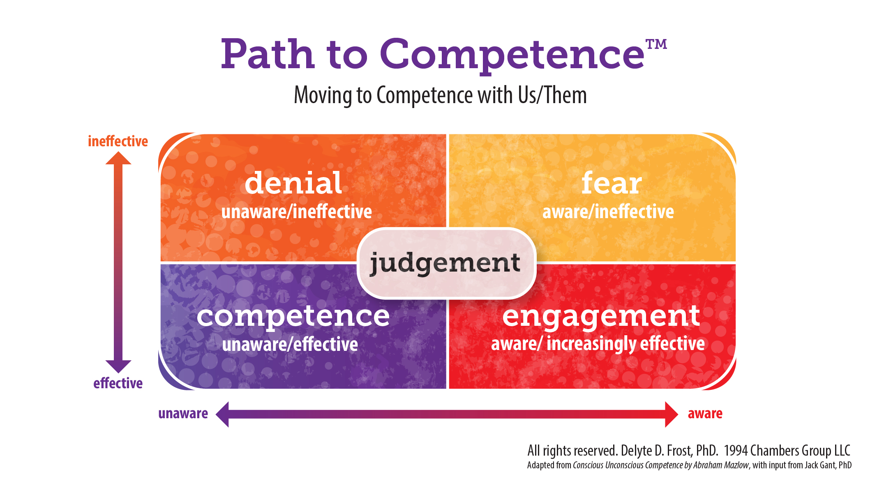

Directions ~ Reflect and note:
- What did you think, say, and do in these different places on the Path to Competence? (Some may apply more to white people than People of Color and Indigenous Peoples)

- What helped you move along your Path to greater capacity, courage, and demonstrated racial competence?

- What have you observed or heard from colleagues?

Box of Denial: unaware/ineffective

- Unaware of their racist attitudes and behaviors
- Stuck at the Individual Level
- PLEs ~ Perfectly Logical Explanations
- Deflecting to a marginalized identity
- That had nothing to do with race! That happens to me/others, too!
- My best friend is Black; I adopted Latinx orphans; I’m married to an Asian American
- You make it worse by segregating us, talking about race; we all got along great before this training; now we’re walking on eggshells
- We are all part of the human race
- I’m part Native American; I’m not white!
- I’m color-blind; I don’t see color!
- I treat everyone the same; I interrupt everyone!
- Tone policing of People of Color: If they would only . . .
- They are too sensitive
- But they are racist, too!
- They play the “race card”—use it as an excuse
- There are microaggressions against whites, too!
- We are post-racial; you are making something out of nothing
- Things are so much better now; what is the big deal?
- I’m not racist! I’m a good one
- I grew up poor; I have no privilege
- Classism is the most important oppression
- Things have swung too far; now whites are discriminated against
- We can’t say anything anymore or joke at all!
- We can’t learn without People of Color
- We just have different opinions
- You can’t lump people together; we’re all individuals
- They just need to work hard and assimilate like my family did
- Get defensive if confronted
- I don’t hate anyone; I’m not racist
- I don’t have any racial prejudice
- There are bad apples in every group
- That was an isolated incident
- I treat people how they treat me
- There is no white privilege; I worked for everything I have

Box of Fear: increasing awareness/ineffective

- See more racist dynamics
- Realize how much they DON’T know or see
- Silent
- Scared of making a misstep, offending, doing something racist
- Walk on eggshells
- Scared, hesitant to respond
- Stay stuck in fear
- Ineffective reactions
- Know they are ineffective
- Giving up: I tried—I’m damned if I do, damned if I don’t
- Can’t do anything right
- Realize how many microaggressions they have done, overlooked
- Realize how they have colluded, gone along to get along
- Guilt, shame, regret
- Defensive, reactive
- Inaction
- Feel powerless, overwhelmed
- Look to others to lead

Box of Judgment: maybe aware or unaware/ineffective

- Blame, judgment of others
- Triggered critiques, confrontations, calling out, unproductive anger
- Not building connections with own group; only want to be with People of Color
- Ineffective engagement
- Self-righteous
- Take no responsibility for developing colleagues
- Shame, blame, guilt, anger towards self
- Swirl in negative self-critique
- Stuck, no effective engagement
- Inaction
- Blame others for our lack of competence
- I’m better than that person; I’m a good one; you are bad
- I am bad; all whites are bad

Box of Engagement: greater awareness/increasingly effective

- Recognize most racist dynamics
- Take more risks to engage
- Respond with increasing effectiveness, still misstep
- Still have to concentrate and focus as engage others
- May need to plan and think through what to do
- Speak up, use a Race Lens in discussions and decisions
- Revise current practices with a Race Lens
- Seek out and use feedback
- Use mentors and coaches
- Practice with others
- Admit racist thoughts and actions
- Listen to the impact of their actions; make amends and change their behaviors
- Take responsibility for developing colleagues

Box of Competence: unaware/show up very effective
- In the flow, present
- Respond effectively without planning or much thought
- Habitual, automatic capacity to respond effectively
- Speak up, take risks, confront effectively
- Committed to stay on their Path to Competence
- Always learning, developing, deepening capacity
- Develop white leaders and change agents
- Support and developing colleagues of color
- Leading organizational and systemic change

Based on the work of Drs. Jack Gant and Delyte Frost, EYCA, Path to Competence
Worksheet developed by Kathy Obear, Ed.D., Center for Transformation and Change
www.drkathyobear.com

