Examples of Hot Buttons, Triggering Comments & Behaviors During Discussions About Race and Racism
Developed by Kathy Obear, Center for Transformation and Change www.drkathyobear.com

(Organized using the model Path to Competence© developed by Drs. Jack Gant and Delyte Frost, Elsie Y. Cross Associates)

To watch Kathy’s webinar about the Path to Competence: https://youtu.be/_6Q61OP58y8
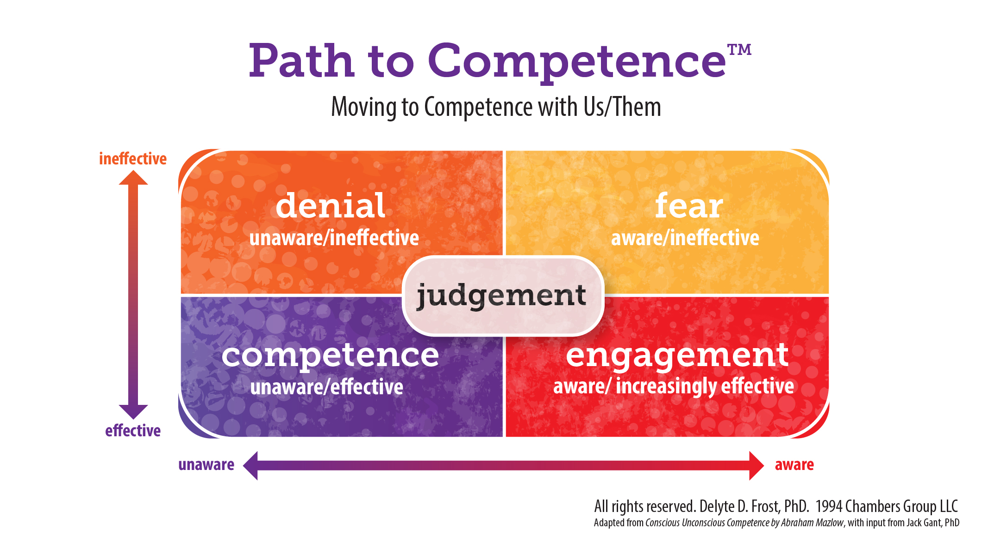

Directions:
- Use a 0-10 scale to rate how much of a hot button or “trigger” each of the following is for you when you are engaging in dialogues about race, racism, white supremacy and/or white privilege.

0 = no emotional reaction
1 -2 = mild level of emotional reaction
3-4 = low-moderate degree of emotional reaction
5-6 = moderate degree of emotional reaction
7-8 = high degree of emotional reaction
  - = extremely high level of emotional reaction

- As you review each item, reflect:
- How, if at all, is the intensity of your emotional and behavioral reaction related to the source of the comment or action? For instance, any difference if from:
  - A family member?
  - Friend?
  - Colleague or team member?
  - Supervisor?
  - Stranger?
  - Political or organizational leader?
  - Someone in a White Accountability Group, workshop or class you are leading?
  - A Person of Color? A white person?
  - You?

- Do you have different reactions if the situation occurred in public or private?
- In these types of situations, how have you responded in ways that furthered learning and development? Organizational Equity and Inclusion goals?
- How have you reacted in ways that were counter-productive? Not aligned with your core values or organizational goals?

When a white person (or you):

Box of Denial (unaware/ineffective)

___ 1. Makes a racist stereotypic, offensive comment.
___ 2. Is set in their ways; refuses to consider new information or differing perspectives.
___ 3. Challenges the validity of the information or statistics being presented.
___ 4. Gets defensive when someone disagrees with them or gives them feedback.
___ 5. Dismisses the conversation as “political correctness” or “cancel culture.”
___ 6. Calls others “snowflakes” or a similar dismissive, pejorative term.
___ 7. Shuts down and disengages.
___ 8. Demands that People of Color teach them and help them learn; represent their group; lead racial equity efforts, etc.
___ 9. Says, “We can’t learn without People of Color!”
___ 10. Does “credentialing”: My best friend is Black! I married a Hispanic man! My kids are mixed! I adopted a child from South Korea! My family marched with Dr. King!
___ 11. Says, “I’m a lesbian (woman, grew up working class, I’m part Native American….), I can’t be racist!”
___ 12. Says, “I know a Person of Color and they don’t feel that way! They say this is a great organization!”
___ 13. Says, “My Black friend has never had any problems from the police.”
___ 14. Says, “I am a human being! We are all part of the Human Race!”
___ 15. Says, “We are all human beings.”
___ 16. Says, “I’m color-blind; I don’t see color!”
___ 17. Says, “You can’t lump people together…we’re all individuals.”
___ 18. Says, “I don't like being called white!”
___ 19. Says, “I don’t hate anyone, I’m not racist.”
___ 20. Says, “I don’t have any racial prejudice.”
___ 21. Says, “There are bad apples in every group!”
___ 22. Says, “I treat people how they treat me.”
___ 23. Says, “I treat everyone the same.”
___ 24. Says, “I never owned slaves!”
___ 25. Says, “My parents worked hard for everything they got. These people are just lazy freeloaders!”
___ 26. Says, “I grew up poor/working class, I don't have any privilege.”
___ 27. Says, “There is no such thing as white privilege.”
___ 28. Says, “Why can’t they just try to fit in more?”
___ 29. Blames individual People of Color for the racist dynamics and structural racism they experience.
___ 30. Supports the deficit narrative: “Most People of Color are under-privileged and haven’t yet had the opportunity to develop the critical skills and competencies needed to succeed.”
___ 31. Says, “I do everything I can to help People of Color!”
___ 32. Says, “They are just a bunch of Welfare Queens; trying to work the system and get something for nothing.”
___ 33. Says, “People of Color are always looking for a free handout and special privileges they didn’t earn.
___ 34. Says, “They just need to work hard and pull themselves up by their bootstraps!”
___ 35. Says, ‘Those people…”
___ 36. Plays “Oppression Olympics:” “Classism is the most important oppression.”
___ 37. Says, “This is how we have always done things and they work well for everyone.”
___ 38. Says, “That is just how the policy is and we can’t change it.”
___ 39. Says, “We have to work within the organizational structures and culture.”
___ 40. Tries to ignore, justify the impact of their behaviors: “That wasn’t my intent!!”
___ 41. Says, “I don’t do that! I’m a good person!”
___ 42. Says, “I can’t control how they feel!”
___ 43. Says, “I’m not responsible for how they misinterpreted my comment!
___ 44. Takes it personally when someone is sharing a pattern of racist dynamics.
___ 45. Is stuck at the Individual/Interpersonal Level: Unable, unwilling to acknowledge Group Level differential experiences and impact.
___ 46. Says, “That was an isolated incident!”
___ 47. Says, “It was just a joke! We can’t say anything anymore!”
___ 48. Says, “I’m not racist!”
___ 49. Says, “That had nothing to do with race! That happens to me, too!”
___ 50. Uses PLEs ~ Perfectly Logical Explanations to try to excuse or rationalize away racist dynamics.
___ 51. Says, “We are damned if we do and damned if we don’t! We can do anything right! What do they want from us?”
___ 52. Says, “What do they want? Nothing will please them!”
___ 53. Says, “It is never enough for them!”
___ 54. Says, “There’s reverse racism! They do it, too! We’re the victim here!”
___ 55. Says, “Things have swung too far; now whites are discriminated against!”
___ 56 Says, “People of Color are racist, too!”
___ 57. Tone polices People of Color: Focuses on and critiques HOW they engaged, not the original problematic behaviors and practices they were addressing: If they would only…. they are too aggressive…“coaches” members of marginalized groups on how to act, think and feel, etc.
___ 58. Says, “People of Color are often loud, argumentative, and unprofessional.”
___ 59. Accuses People of Color who call them in: “You attacked me!”
___ 60. Says, “They are too sensitive; always over-reacting!”
___ 61. Says, “They are always playing the Race Card over nothing!”
___ 62. Says, “There is no systemic racism in this organization.”
___ 63. Says, “People of Color need to ‘get over it’ and stop using the past as an excuse for their lack of success.
___ 64. Says, “There are microaggressions against whites, too!”
___ 65. Says, “We are post-racial now!”
___ 66. Says, “Things are so much better now; look how far we have come!”
___ 67. Says, “I know all I need to know!”
___ 68. Says, “It’s not as bad here as most other places.”
___ 69. Says, “Change takes time. You have to be patient.”
___ 70. Says, “You are pushing too hard, lighten up!”
___ 71. Says, “If you keep pushing, you will lose people and set us back years!”
___ 72. Says, “You are creating divisions and hostility by talking about race!”
___ 73. Says, “You make it worse by segregating us, talking about race.”
___ 74. Says, “Why are we always talking about race!”
___ 75. Says, “We need to talk about other issues of diversity!”
___ 76. Deflects the conversation to focus on one of their marginalized identities.
___ 77. Debates, argues, and resists.
___ 78. Says, “We just have different opinions, different facts.”
___ 79. Claims a false equivalency.
___ 80. Is stuck in their heads, intellectualizing. Refuses to own and talk about their emotions.
___ 81. Minimizes and discounts the experiences and comments of People of Color.
___ 82. Has distracting nonverbal behaviors as people share: eye rolling, deep sighs, head shaking, side conversations, look at phone, etc.
___ 83. Interrupts and talks over People of Color or other white people.
___ 84. Refuses to believe the lived experiences of colleagues of color.
___ 85. Says, “This ‘data’ is just anecdotal. Probably from under-performing staff!”
___ 86. Rescues other white participants who are given feedback.
___ 87. Ignores or minimizes the racial trauma colleagues of color are experiencing from national events and the organizational climate.
___ 88. Escalates the degree of conflict; the conversation feels “out of control”
___ 89. Says, “I’m not open to your feedback!”
___ 90. Says: I asked my friends of color and they say I am not a racist; No one has ever complained about me being a racist.

Box of Fear (more aware; still ineffective)
___ 91. Is quiet; refuses to participate in discussions or activities.
___ 92. “Walks on eggshells” and acts more distant and more formal with People of Color.
___ 93. Seems to use tears to distract, re-center themselves, weaponize them, etc.
___ 94. Is all talk, no meaningful action.
___ 95. Is performative: Uses all the current terms and lingo as well as academic theory and concepts, but still behaves in racist ways.
___ 96. Stays at the conceptual level, uses inaccessible language and terms.
___ 97. Doesn’t speak up to interrupt racist dynamics.
___ 98. Tries to excuse their silence and inaction: I’m afraid to make a mistake, say something racist; Afraid to make things worse or cause harm…
___ 99. Demonstrates a lack of integrity: Says one thing, does another.
___ 100. Seeks approval, validation, and recognition from People of Color.
___ 101. In an effort to interrupt the difficult conversation and avoid discomfort, says, “Let’s table this for now and form a task force to research this and suggest next steps.”
___ 102. Says, “We need to do an organizational survey to see how bad this really is” - as a resistance strategy to slow or stall change efforts knowing that leaders will eventually move on to the next crisis and lose interest and energy for addressing issues of race and racism.
___ 103. Rushes to a solution without fully embracing the emotions and cumulative impact.
___ 104. Tries to smooth over disagreement and conflict; create harmony.
___ 105. Is overly aggressive in their reactions to other white participants.
___ 106. Appears timid, hesitant.
___ 107. Gives up: “This is too hard! I feel so powerless, helpless! I am so tired! I need to take a break from this work.”
___ 108. Says, “I’ve tried to get some leaders to care about racism, but I don’t have any influence with them.”
___ 109. Says, “I tried to speak up more but a colleague of color called me out for doing it wrong, so I need to step back for now and keep listening.”
___ 110. Says, “This is so overwhelming! I don’t think I’m making any progress.”
___ 111. Says, “Am I just fooling myself I am making a difference? When I am really still colluding and maintaining the status quo?”
___ 112. Says, “I get all this white privilege! I feel so guilty! How do I give it up?”

Box of Judgment (Stuck in guilt and/or shame; judging and blaming self and/or others)
___ 113. Says, “I am so ashamed!”
___ 114. Says, “I am so guilty!”
___ 115. Says, “I’m a horrible person!”
___ 116. Is deeply triggered, expressing intense emotions.
___ 117. Refuses to look at their own racist attitudes and behaviors.
___ 118. Tries to avoid self-work by redirecting the conversation to family racist dynamics or external societal racism.
___ 119. Distances from other white people.
___ 120. Judges other white people: “White people are so racist!” “They’re a leader, they should know better!” “How did they get to be a leader and be so incompetent about racism!” “You say racist things, how dare you confront me?” “You’re a hypocrite!” “You say you are committed to equity and inclusion, but you are still such a racist!”
___ 121. Criticizes, gossip abouts, and finds fault with white people.
___ 122. Critiques how co-conveners are running the White Accountability Group or training as a way to show superiority.
___ 123. Says, “I’m better than these whites!” Engaging in Woke Olympics; Social Justice Arrogance, etc.
___ 124. Says, “I’m woke!”
___ 125. Competes to be the most “woke” white person in the room.
___ 126. Calls out other white participants, rather than calling in.
___ 127. Has a condescending, arrogant, self-righteous or patronizing tone.
___ 128. Competes with other whites to be “the good white:” the best ally, the one People of Color let into their circle, etc.
___ 129. Aggressively confronts any white person who says or does something racist; piles on the feedback to distance from them and prove who is a better ally.
___ 130. Gives unsolicited advice to others.
___ 131. Says, “Whites are boring; I’d rather hang out with my friends of color!”
___ 132. Takes no responsibility for developing white colleagues.
___ 133. Aggressively calls someone racist to shut them down and prove they are better than them.
___ 134. I’ve worked with them for years and never knew they were so racist!
___ 135. Says, “These white people are so racist!” as they separate themselves from them.

Additional common triggers for you:

I am deeply grateful for the input and feedback from participants in trainings and White Accountability Groups over the years; and especially for the ideas from my colleagues Beth Yohe, Beth Douthirt Cohen, Rachael Forester, Shannon Joliff Detorre, and Victoria Farris.

Developed by Kathy Obear, kathy@drkathyobear.com www.drkathyobear.com (

